

Inverter Layout project

Layout and Schematic Images & Results



October 10, 2024

Mark Ivey

UTD EECT 6325, VLSI Design

In this project, I was able to create an inverter based on the following specifications:

* WP: 1.4 µm
* WN: 1.0 µm
* CLOAD: 22 fF

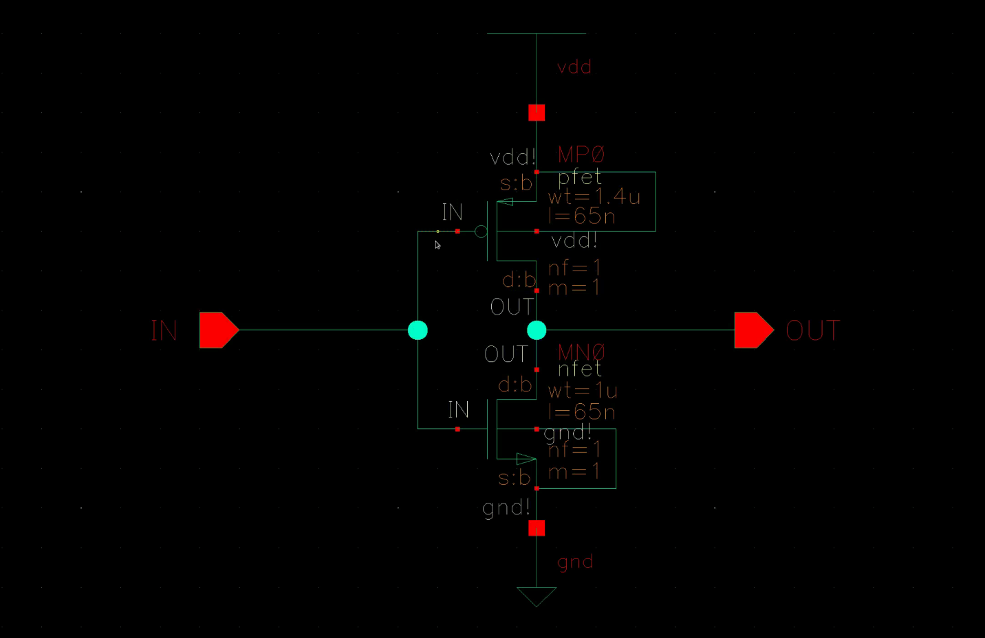

Figure 1: Inverter Schematic

With my design, I was able to achieve a height and width of 3.42 µm by 0.705 µm, measuring from the outer edges of VDD to GND.

The pin pitch of the in and out pads is 0.26 µm,

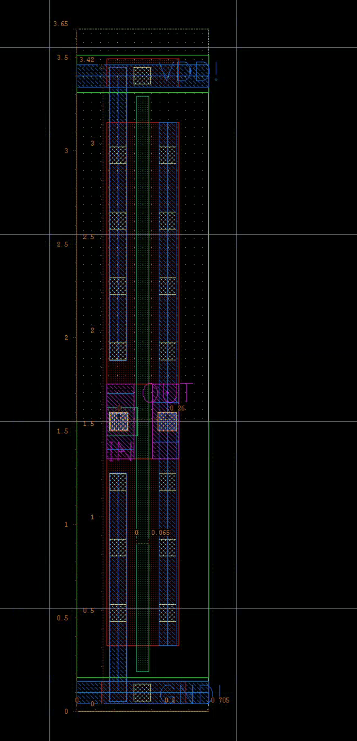

Figure 2: Inverter Layout

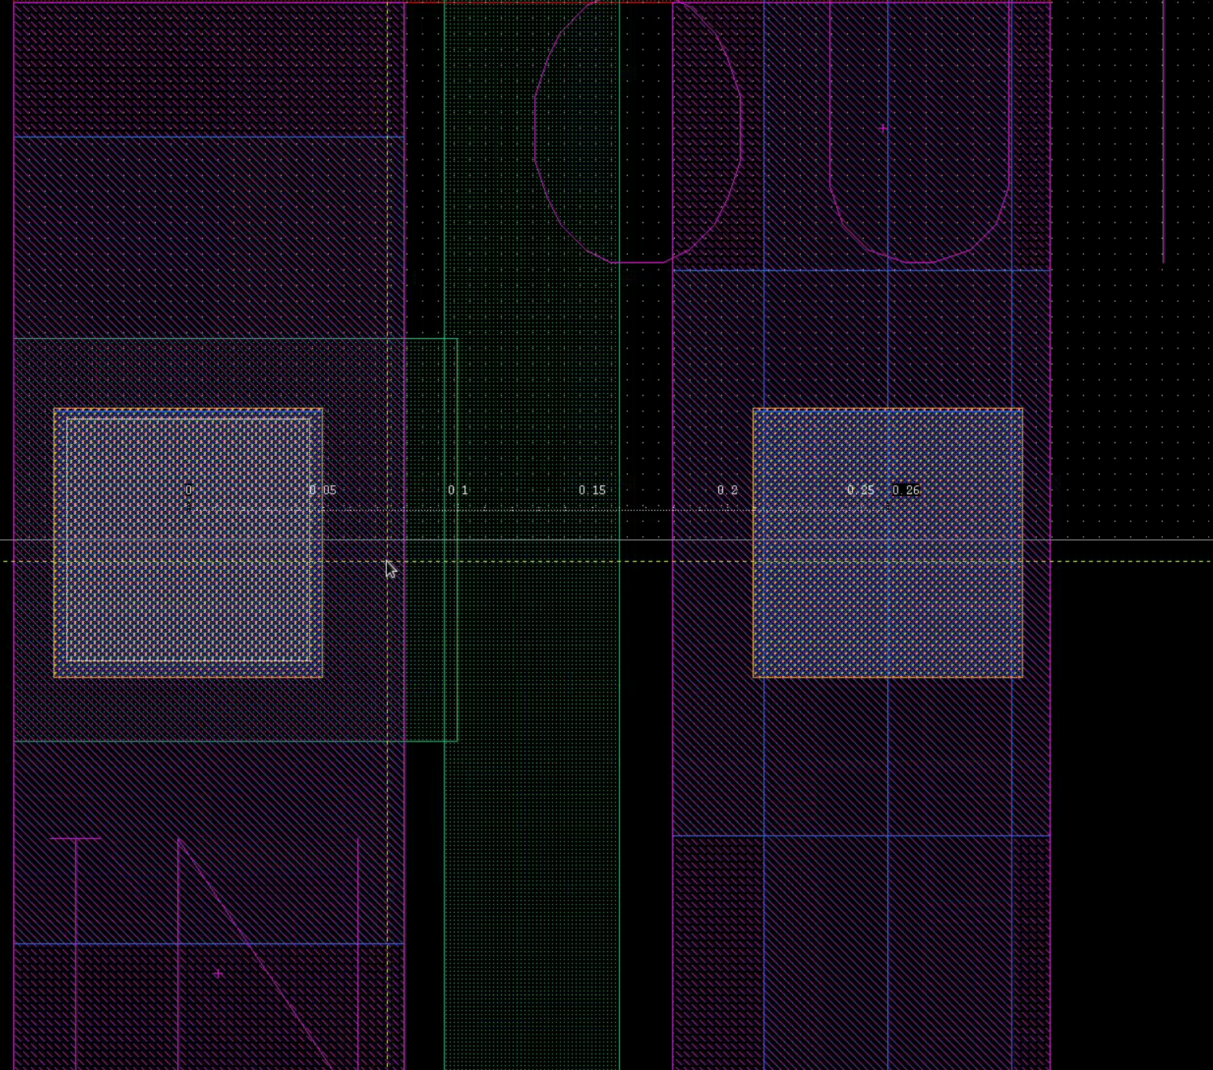

Figure 3: Pin pitch of 0.26 µm

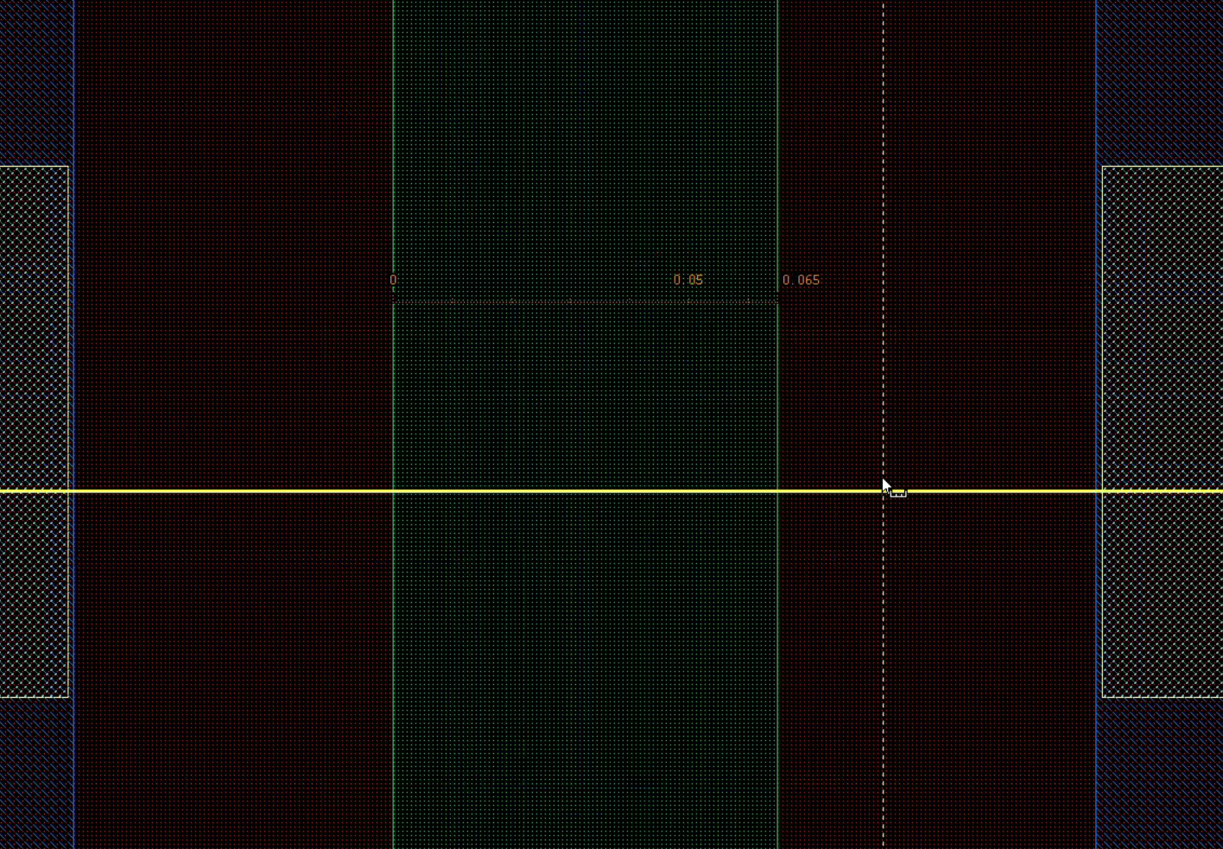

Figure 4: Gate Width

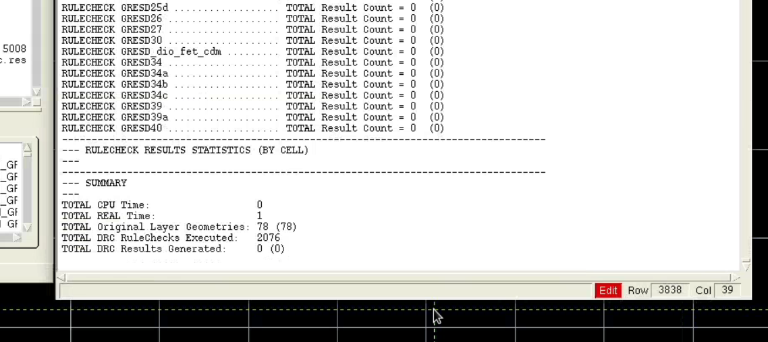

Figure 5: DRC Summary

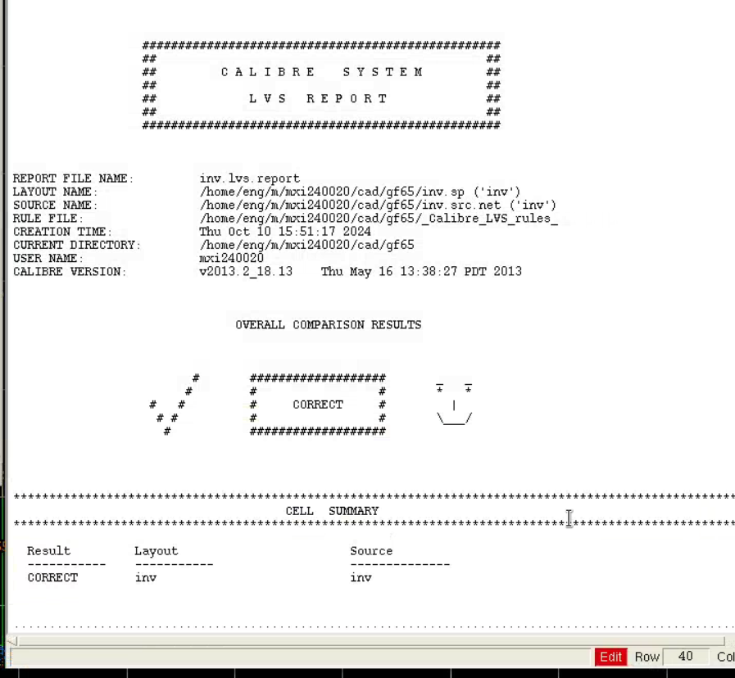

Figure 6: LVS Report

Using HSpice, I was able to show the inverter has the following characteristics:

* Delay:
  + tpHL: 40.6 ps
  + tpLH: 60.9 ps
* Slew Rate:
  + tHL, 20 to 80%: 44.1 ps
  + tLH, 80 to 20%: 75.1 ps

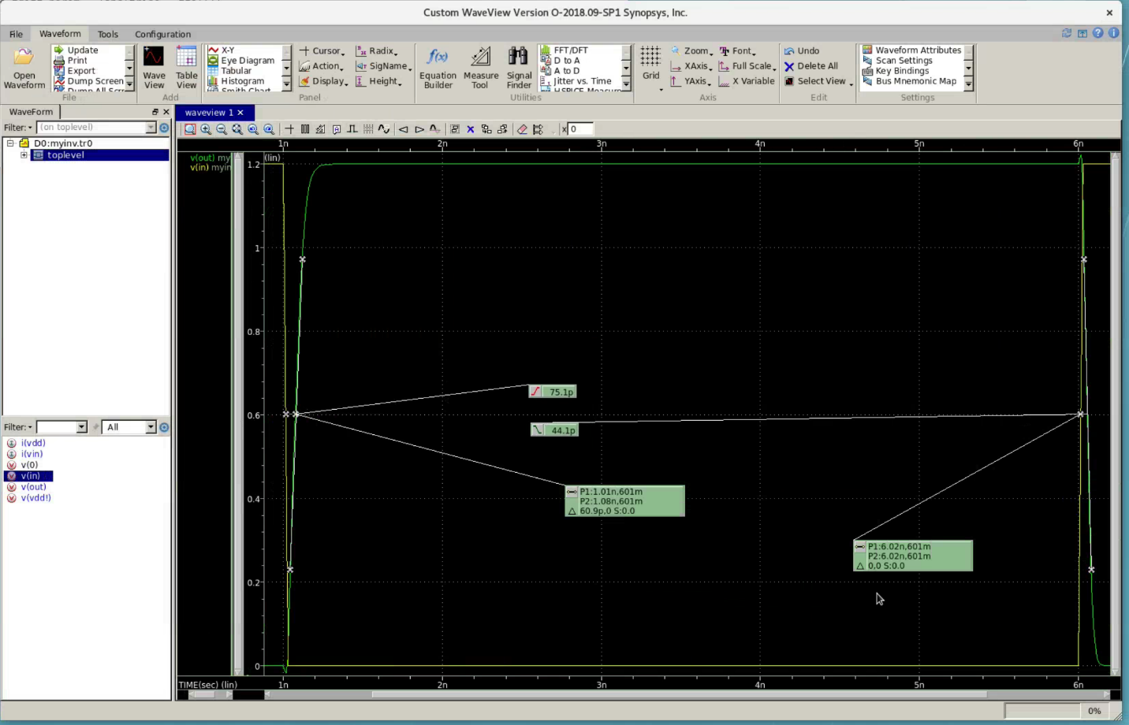

Figure 7: Slew and Delay

**Hspice Test Setup File**

********* inverter test *********

.include "/proj/cad/library/mosis/GF65_LPe/cmos10lpe_CDS_oa_dl064_11_20160415/models/YI-SM00030/Hspice/models/design.inc"

$ /home/eng/m/mxi240020/cad/gf65/inv_LVS/inv.pex.sp

.include "/home/eng/m/mxi240020/cad/gf65/inv_LVS/inv.pex.sp"

.option post runlvl=0

xmytele GND! OUT VDD! IN inv

vdd VDD! GND! 1.2v

vin IN GND pwl(0ns 1.2v 1ns 1.2v 1.03ns 0 6ns 0v 6.03ns 1.2v 7.2ns 1.2v)

cout OUT GND! 22f

$ my Transient analysis

.tr 100ps 7.2ns

.tr 100ps 7.2ns sweep WP 1u 9U 0.5u

.measure tran trise trig v(IN) val=0.6v fall=1 targ v(OUT) val=0.6v rise=1

.measure tran tfall trig v(IN) val=0.6v rise=1 targ v(OUT) val= 0.6v fall = 1

.measure tavg param = '(trise + tfall)/2'

.measure tdiff param = 'abs(trise - tfall)'

.measure delay param = 'max(trise, tfall)'

.end

**Extracted Spice Netlist**

Inv.pex.sp

* File: /home/eng/m/mxi240020/cad/gf65/inv_LVS/inv.pex.sp

* Created: Sun Oct  6 17:56:57 2024

* Program "Calibre xRC"

* Version "v2013.2_18.13"

*

.include "/home/eng/m/mxi240020/cad/gf65/inv_LVS/inv.pex.sp.pex"

.subckt inv  GND! OUT VDD! IN

*

* IN  IN

* VDD!  VDD!

* OUT OUT

* GND!  GND!

XD0_noxref N_GND!_D0_noxref_pos N_VDD!_D0_noxref_neg DIODENWX  AREA=2.15e-12

+ PERIM=6.3e-06

XMMN0 N_OUT_MMN0_d N_IN_MMN0_g N_GND!_MMN0_s N_GND!_D0_noxref_pos NFET L=6.5e-08

+ W=1e-06 AD=1.61e-13 AS=1.56e-13 PD=2.322e-06 PS=2.312e-06 NRD=0.1 NRS=0.095

+ M=1 NF=1 CNR_SWITCH=1 PCCRIT=0 PAR=1 PTWELL=0 SA=1.56e-07 SB=1.61e-07 SD=0

+ PANW1=6.5e-15 PANW2=3.25e-15 PANW3=3.25e-15 PANW4=3.25e-15 PANW5=3.25e-15

+ PANW6=6.5e-15 PANW7=1.3e-14 PANW8=1.3e-14 PANW9=1.3e-14 PANW10=0

XMMP0 N_OUT_MMP0_d N_IN_MMP0_g N_VDD!_MMP0_s N_VDD!_D0_noxref_neg PFET L=6.5e-08

+ W=1.4e-06 AD=2.254e-13 AS=2.184e-13 PD=3.122e-06 PS=3.112e-06 NRD=0.0714286

+ NRS=0.0678571 M=1 NF=1 CNR_SWITCH=1 PCCRIT=0 PAR=1 PTWELL=1 SA=1.56e-07

+ SB=1.61e-07 SD=0 PANW1=6.5e-15 PANW2=3.25e-15 PANW3=3.25e-15 PANW4=3.25e-15

+ PANW5=9.425e-14 PANW6=1.0075e-13 PANW7=2.6e-14 PANW8=2.6e-14 PANW9=5.2e-14

+ PANW10=4.875e-14

*

.include "/home/eng/m/mxi240020/cad/gf65/inv_LVS/inv.pex.sp.INV.pxi"

*

.ends

*

*

Inv.pex.sp.pex

* File: /home/eng/m/mxi240020/cad/gf65/inv_LVS/inv.pex.sp.pex

* Created: Sun Oct  6 17:56:57 2024

* Program "Calibre xRC"

* Version "v2013.2_18.13"

* Nominal Temperature: 27C

* Circuit Temperature: 27C

*

.subckt PM_INV%GND! 1 6 14 16 20

c27 14 0 4.40239e-19

r28 11 14 0.382777

r29 9 16 0.0289663

r30 9 11 0.0767497

r31 6 20 10

r32 4 16 0.0162764

r33 4 6 0.987955

r34 1 11 30

.ends

.subckt PM_INV%OUT 3 8 16 19 21 22

c34 16 0 1.70551e-19

r35 16 25 0.118479

r36 16 24 0.128621

r37 15 19 0.0398801

r38 15 16 1.7

r39 11 21 30

r40 8 11 0.868805

r41 8 25 0.77696

r42 8 21 10

r43 3 24 0.700008

r44 3 22 10

.ends

.subckt PM_INV%VDD! 1 6 17 22

r25 14 17 0.407065

r26 12 19 0.0289663

r27 12 14 0.0767497

r28 10 22 30

r29 6 10 0.868805

r30 6 22 10

r31 4 19 0.0162764

r32 4 10 0.55107

r33 1 14 30

.ends

.subckt PM_INV%IN 4 6 9 10 12 14 16 19 20

c44 20 0 1.20466e-19

c45 19 0 1.49221e-19

r46 20 23 25

r47 19 20 1.7

r48 16 19 0.0432845

r49 9 23 3.96633

r50 9 10 0.717752

r51 6 14 68.3465

r52 5 10 4.92266

r53 5 6 12.2047

r54 4 10 4.92266

r55 3 12 48.8189

r56 3 4 12.2047

.ends